Machine Design

-Assignment 1-

Hakan Polat

We were asked to implement a C-core with the given dimensions in Figure 1 and simulate it for different material, different MMF, for linear and nonlinear BH curves and also calculate the inductance theoretically and practically.

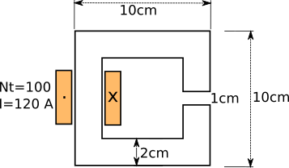

Figure 1: Dimensions of the C-core

I started my design with the image in Figure 2. I added an extra box to the airgap in order to to be able to manipulate the mesh size at that location for a better result and avoid unnecessary work.(2d is fast however it may take long times in the next assignments). In addition the 2nd circle is also for the meshing purposes.

Note: The lines are for calculation purposes.

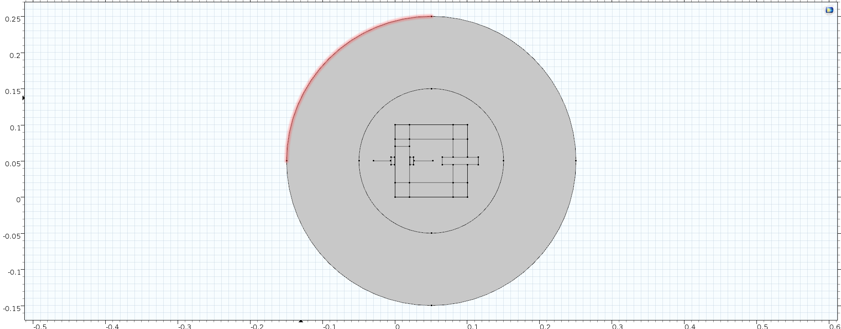

Figure 2: Geometry of the C-core

Using a linear iron core with 1000 permiability

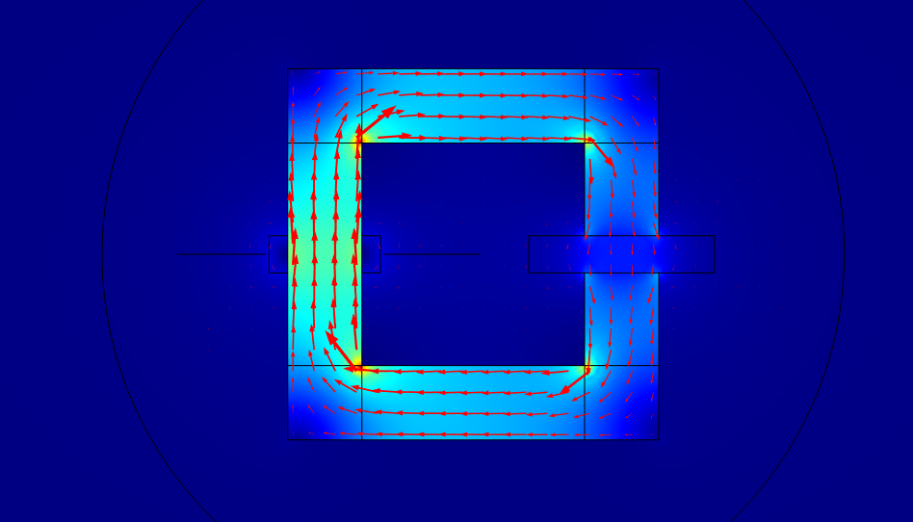

Figure 3: Iron core with 1000 relative permiability

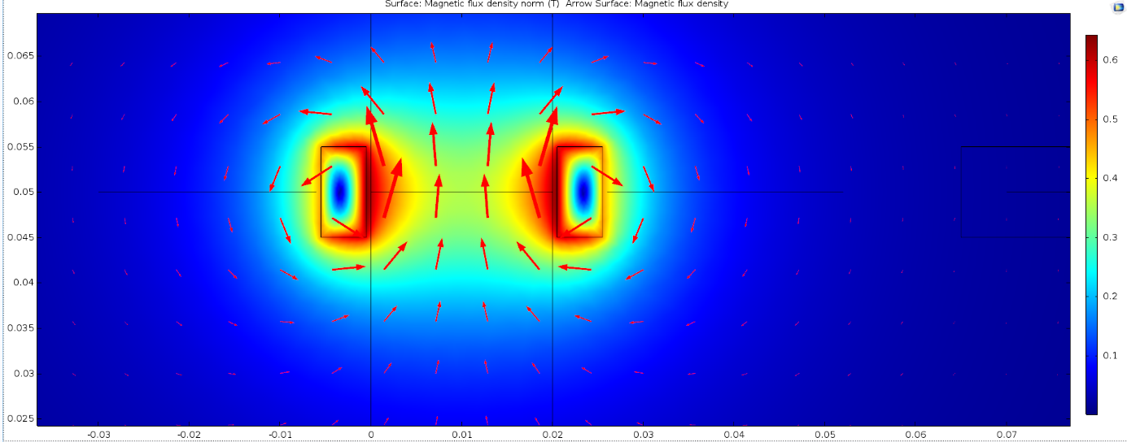

Figure 3: Air core

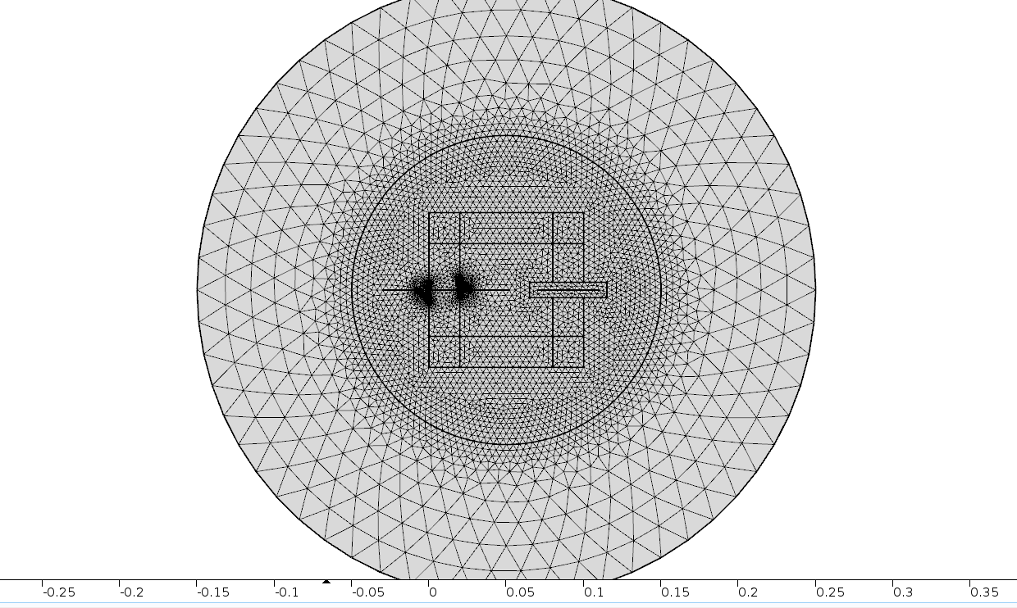

Figure 4: Mesh of the design

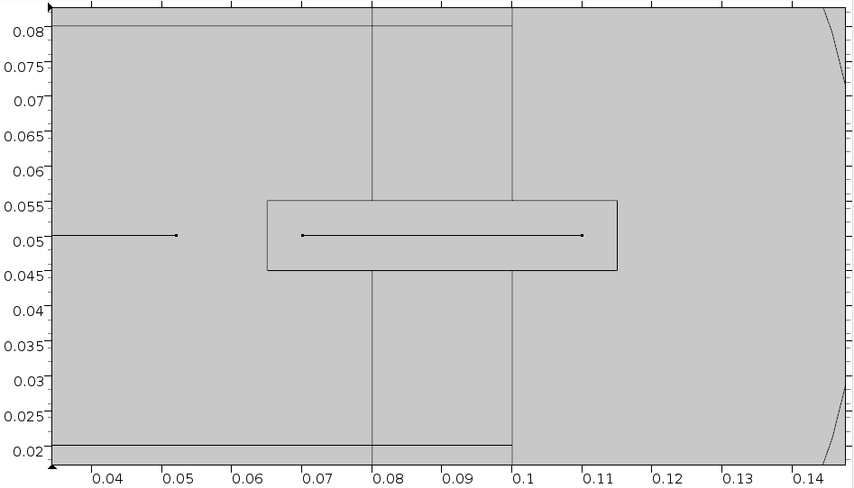

Figure 5: The line that is used in order to obtain a B-graph in the Airgap

By taking the B-field on every point on the line we can have a better look at the fringing effect.

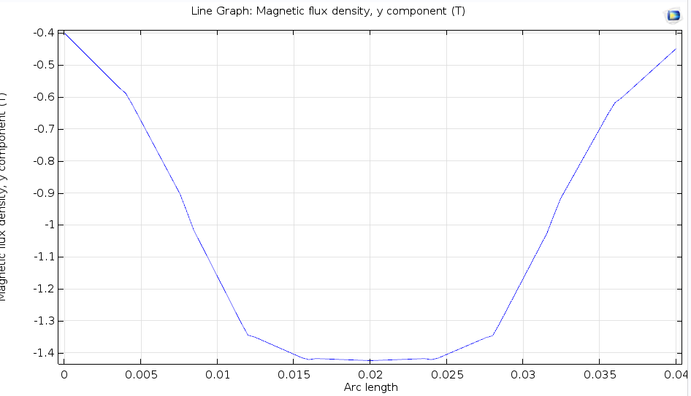

Figure 6: B-field on the airgap

Note: Negative B field is due to the direction of the flux.



Figure 7: Leakage flux integration line

By integrating the Bfield on a line where the leakage flux rotates we can find analytically the value of the Flux. (Note normally Flux=BxA however since the length in the Z-axis is 1m there is no need to integrate that direction)

Φleak = 0.01755 Wb

We know that L=(φ\*N/I)

From here we can calculate the inductance

Lleakage= 0.01755\*100/120= 0.014H

Similarly by using the same approach it is also possible to calculate the inductance of the core. ( Using the unselected line in the middle in Figure 7)

Φcore=0.072 Wb

Lcore=0.072\*100/120= 0.06 H

I was unable to simulate with a BH-curve since I took many errors in the process however as I am expecting that as I increase the MMF the result that I get will be more similar to the air core case. Simulation with nonlinear BH curve will be asked.